EFFICIENT PAGE REPLACEMENT ALGORITHM SIMULATOR

By:
Roll no. 36 Siddharth Sharan
Roll no. 45 Jyoti Mandal
Roll no. 57 Soumya Suresh

PROJECT OVERVIEW
Introduction
Page replacement algorithms are very important in the present day operating systems to manage memory. They are responsible for choosing which pages to replace when a page fault happens, thus affecting the system performance. This project is to design and develop a simulator that can be used to test and compare different page replacement algorithms directly by the users.
Objective
This simulator is aimed first and foremost at making all these productive visuals and performance matrices for page replacement algorithms, of course, these aim at leading users to find out the most capable algorithms in handling memory. By mimicking real-life scenarios, the project offers the users to make use of different algorithms to experiment with and judge by the effectiveness they deliver in controlling memory.
Key Features
- Algorithm Selection: Statistics show that users can select FIFO (First-In-First-Out), LRU (Least Recently Used) , OPT(Optimal page replacement) separately.
- Reference String Input: In addition to that, they can also input a sequence of page requests to simulate memory access patterns.
- Frame Allocation: Along with the fact that they can define the number of page frames, it comes as an extra advantage.
- Step-by-Step Execution: A sequence of steps will be demonstrated by the simulator, refreshing the memory frames, and alerting on faults.
- Performance Metrics: To that extent, users may look for the program to figure out the total number of page faults which will enable them to see how efficient the different algorithms are.
- User-Friendly Interface: On the other hand, the memory frame is drawn on the screen which dynamically animates the memory frame switches.
Significance
This simulator is a primordial teaching tool for students, researchers, and professionals who are studying the topics of computer science and operating systems. By providing students with the opportunity to have hands-on experience with different page replacement techniques, they can easily see and understand what memory management does to the system's performance and how different algorithms have different levels of suitability in different situations.

Expected Outcome
By using this simulator, users will be able to:
Understand the working principles of different page replacement algorithms.
Compare performance metrics such as page faults and efficiency.
1. User Interface (UI) Module
- Objective: Provide an interactive front-end for user input and result visualization.
- Components:
Algorithm Selection: Dropdown menu to choose FIFO, LRU, or Optimal algorithms.
Reference String Input: Text box to enter a sequence of page requests.
Frame Count Input: Input field to define the number of available memory frames.
Run Simulation Button: Triggers the execution of the selected algorithm.
Results Display: Table showing step-by-step memory states, highlighting page faults.
Performance Metrics: Displays total page faults for comparison.
Technologies: React, TailwindCSS
2. Page Replacement Algorithm Module
- Objective: Implement and execute different page replacement algorithms.
- Algorithms Implemented:
FIFO (First-In-First-Out): Replaces the oldest page in memory.
LRU (Least Recently Used): Replaces the least recently accessed page.
OPT (Optimal Page Replacement): Replaces the page that will not be used for the longest time in the future.
Technologies: Python
3. Simulation Engine Module
Objective: Process user inputs and execute the selected algorithm step by step.
Functionalities:
Parse reference string and frame count.
Execute the selected algorithm and track page hits and faults.
Store intermediate steps for visualization.
Return final results for UI rendering.
Technologies: Python, Data Structures (Lists, Queues, Dictionaries), tkinter
4. Visualization and Metrics Module
Objective: Display real-time updates on page replacement operations.
Features:
Memory Frame Visualization: Table showing frames and page replacements.
Page Fault Indicator: Highlights when a page fault occurs.
Performance Metrics: Calculates total page faults for comparison.
Technologies: React, TailwindCSS
GitHub Integration & Version Control Module
Objective: Track code changes and enable collaboration.
Functionalities:
Maintain repository structure with UI, algorithm logic, and documentation.
Store revision history for tracking updates.
Provide GitHub link for open-source collaboration.
Technologies: Git, GitHub

Functionalities of the Efficient Page Replacement Algorithm Simulator
1. Algorithm Selection
- The user can select any of the following page replacement algorithms:
- FIFO (First-In-First-Out) - Replaces the oldest page within the memory.
- LRU (Least Recently Used) - Replaces the least recently accessed page.
- OPT (Optimal Page Replacement) - Replaces the page that will not be used for the longest time in the future.
- How it Works: The user selects an algorithm choice from a dropdown list.
2. Reference String Input
- Users can enter a sequence of requests for pages to simulate memory access patterns.
- Example Input: 7 0 1 2 0 3 4 2 3 0 3 2
- How it Works.
- The system will process this input to be used by the simulation.
- It will validate the reference string to ensure it is in proper format.
3. Memory Frame Allocation
- Number of memory frames may be defined by users, e.g., 3, 4, or even 5.
- How it Works:
- The user enters a number for frame allocation.
- This value is used by the simulator to determine page replacements.

4. Stepwise Simulation Execution
- The system runs the chosen algorithm stepwise and shows different states of memory.
- How it Works:
The simulator processes requests for pages one by one.
A page gets added or replaced depending on the chosen algorithm.
Every step gets recorded for visualization.

5. Page Fault Tracking
- Counts page faults, and marks the occurrence.
- How it Works:
- The occurrence of a page in memory causes a page fault.
- It increments the page fault counter in the system and marks the step.

6. Performance Metrics Calculation
- The performance metrics of every algorithm are calculated and shown by the simulator.
- Metrics Provisioned:
Total Page Faults – Total number of page faults during the execution.
Hit/Miss Ratio (if required) – The ratio of hits achieved on pages to misses.
- How it Works: During and after execution, dynamically update performance metrics.

7. Real-Time Illumination
- The state of memory is displayed at each step through tables with interactive highlighting.
- How it Works:
The changing memory frames get updated dynamically in the UI.
Every row corresponds to a memory snapshot during a specific step.

8. Empty and New Run Simulation
- Users may reset the simulation and perform a different test.
- How it Works:
Click Reset, and remove all the inputs and results.
- New settings may be used to run a new simulation.

9. GitHub Versioning and Collaboration
This project is being tracked and kept on GitHub.
- How it Works:
Just push code changes to a GitHub repository.
Users will access old versions of the project or contribute to it.

10. Future Improvements (Scope of Development)
Some possible improvements are:
- Graphical Animation – Animatedly display how pages are replaced.
- More Algorithms – Clock Algorithm, Second-Chance, etc.
- Comparison Mode – Multiple algorithms executed in parallel with one another.

Programming Languages:
- Python
Libraries and Tools:
- Python 3.x
- tkinter
- Custom Python Modules (page_replacement.py & visualization.py)
Other Tools:
- GitHub (for version control and collaboration)
- Git (for tracking code changes)

Flow Diagram
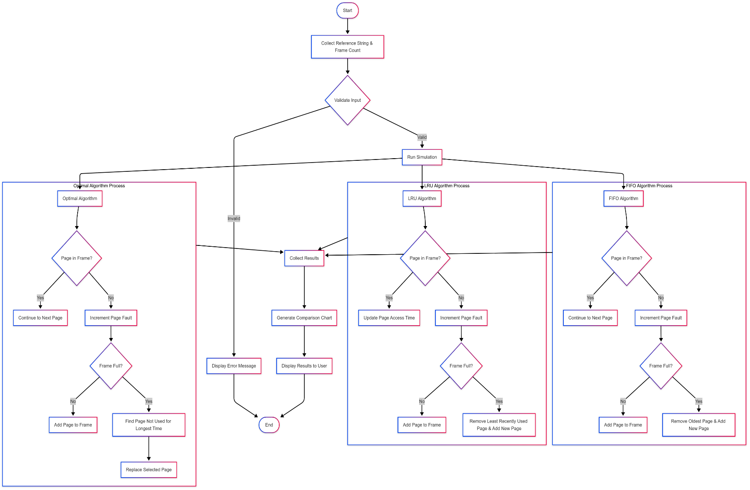
Revision Tracking on GitHub
- Repository Name: Efficient-Page-Replacement-Algorithm-Simulator
- GitHub Link:
Conclusion
The Efficient Page Replacement Algorithm Simulator effectively simulates and visualizes various page replacement policies, enhancing the comprehension of memory management in contemporary operating systems. Through the utilization of FIFO, LRU, and Optimal algorithms, the simulator offers an interactive environment where users are able to enter reference strings, assign memory frames, and study the effect of various policies on page faults. Step-by-step execution and real-time visualization facilitate users to comprehend the fundamental concepts of page replacement better.
This project is a helpful pedagogical and analytical resource for students, researchers, and professionals in computer science and operating systems. It provides them with the facility to try different algorithms, test their efficiency, and learn practical lessons about memory management. The simulator also helps in better understanding how operating systems manage memory for optimization, thus making it a valuable resource for learning and research.
Future Scope
• More Algorithms to be Implemented: Subsequent versions can include more sophisticated page replacement methods like Clock, Second-Chance, and Least Frequently Used (LFU) algorithms to increase the scope of comparisons.
• Graphical Animations for Improved Visualization: Introducing animated graphical representations of memory frames and page replacements will make it even more interactive and easy to use.
• Comparison Mode: Providing an option to execute multiple algorithms at once and show a side-by-side comparison of performance via graphs and charts.
• Cloud-Based Deployment: Hosting the simulator as a web application will bring it to the masses, and users will be able to execute simulations without requiring local software installations.
• Machine Learning Integration: Investigating the application of AI and machine learning algorithms to forecast best page replacement policies from real-world usage trends.
• Improved User Interface: Refining the UI/UX layout to enhance the interactivity and usability of the simulator.
• Mobile Support: Adding support for mobile and tablet devices to expand usability across platforms.

References
- Wikipedia - Page Replacement Algorithms: https://en.wikipedia.org/wiki/Page_replacement_algorithm
- GeeksforGeeks - Page Replacement Algorithms: https://www.geeksforgeeks.org/page-replacement-algorithms/
- TutorialsPoint - Virtual Memory and Page Replacement: https://www.tutorialspoint.com/operating_system/os_virtual_memory.htm
- IBM Documentation - Memory Management in Operating Systems: https://www.ibm.com/docs/en/aix/7.2?topic=memory-management
- Coursera - Operating Systems and Memory Management: Online Course by University of Colorado

AI-Generated Project Elaboration/Breakdown Report

Project Overview
The Real-Time Process Monitoring Dashboard is a Python-based tool designed to provide live tracking of CPU and memory usage while enabling process management through a user-friendly graphical interface. It includes graphical representation of system statistics and features deadlock detection and recovery mechanisms.

Modules & Roles
Modules | Roles
Monitoring Module | Fetches and updates CPU & memory usage in real-time using psutil.
Graphical Representation Module | Displays real-time CPU & memory usage trends visually.
Process Management Module | Lists top 10 CPU-consuming processes and enables termination.
Deadlock Detection Module | Identifies and resolves deadlocks in process management.
User Interface Module | Implements GUI using tkinter with progress bars, process display, and real-time stats.

Key Functionalities
- Real-Time CPU & Memory Monitoring – Displays live system stats with progress bars.
- Graphical Representation – Visualizes CPU and memory usage trends dynamically.
- Top Process Listing – Shows the top 10 CPU-consuming processes, sorted in descending order.
- Process Control – Allows termination of selected processes with error handling.
- Deadlock Detection & Recovery – Identifies and resolves system deadlocks to ensure smooth execution.
- Auto-Update – Refreshes every 2 seconds to provide up-to-date system stats.
Technology Used
- Python – Backend logic.
- tkinter – GUI for user interaction.
- psutil – System monitoring (CPU, Memory, Processes).
- Matplotlib (if used for graphical representation).
Execution Plan
- Install dependencies (pip install psutil).
- Implement CPU & memory tracking with real-time updates.
- Display top processes dynamically in the GUI.
- Integrate graphical representation for better visualization.
- Add process termination feature with error handling.
- Implement deadlock detection & recovery mechanism.
- Test and refine UI for smooth operation.
Problem Statement
Real-Time Process Monitoring Dashboard Develop a real-time system monitoring tool that displays CPU usage, memory consumption, and top-running processes. The application should enable users to monitor and manage processes efficiently, ensuring optimal system performance.

